Irregular Polygonal Shapes
# Source: AI Source: Provided by: [Data Path: Persons Table -> ID Column: 1, Name_En Column: Motasem Essam] -> From: [ChatGPT] on [7/25/2026]
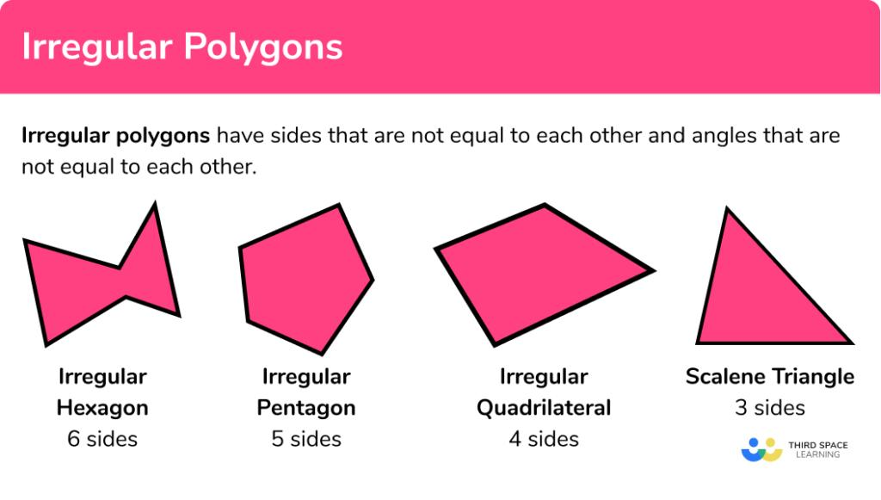
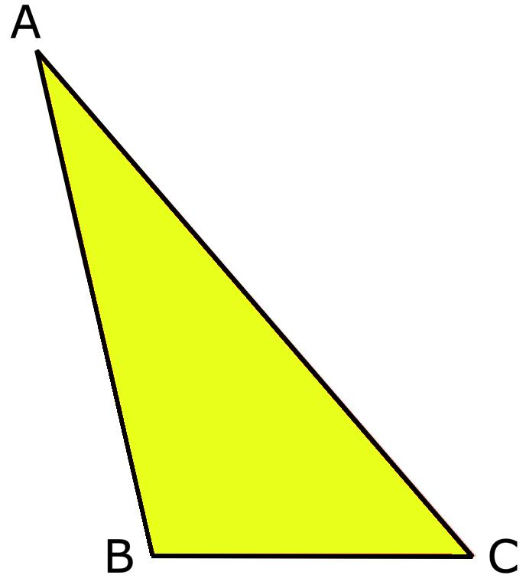
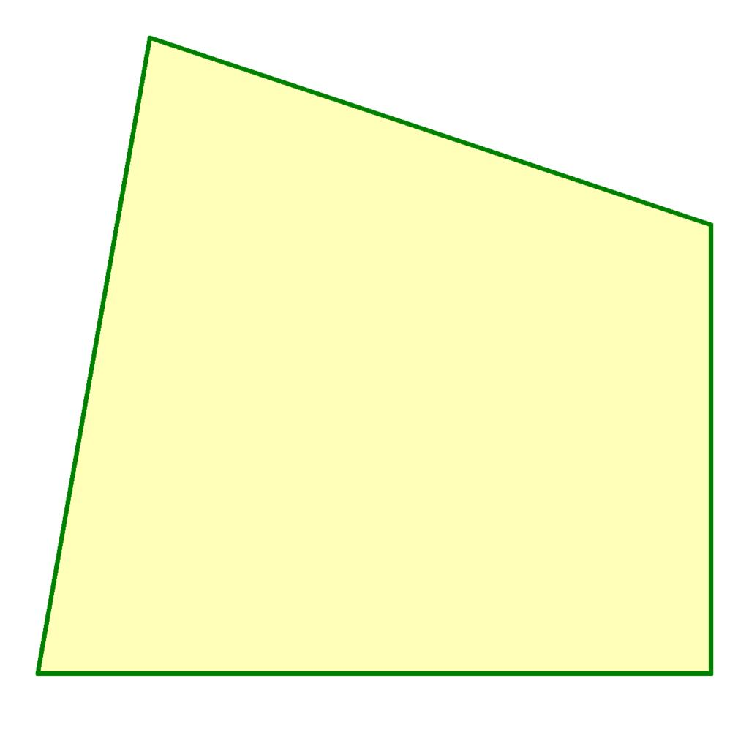
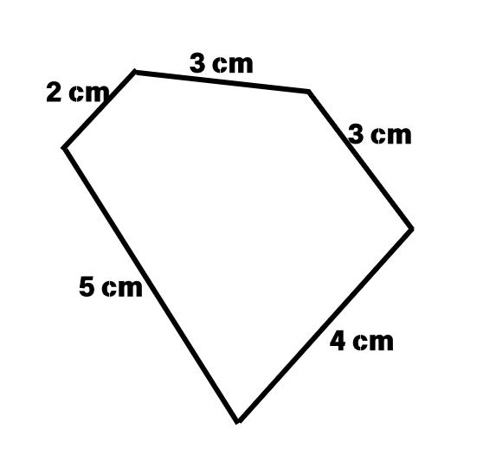
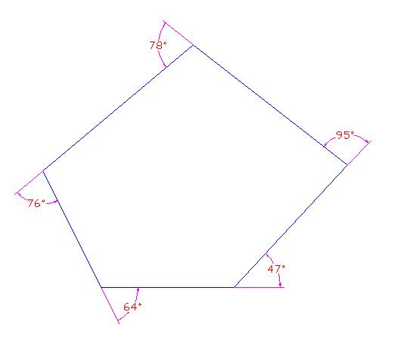
Types of Irregular Shapes – Irregular Polygonal Shapes

Definition
# Source: AI Source: Provided by: [Data Path: Persons Table -> ID Column: 1, Name_En Column: Motasem Essam] -> From: [ChatGPT] on [7/25/2026]
An Irregular Polygonal Shape is a closed two-dimensional polygon whose sides and/or interior angles are not all equal.
It is a type of irregular shape that is formed entirely by straight line segments. Unlike regular polygons, irregular polygons do not have uniform side lengths or equal angle measurements.
Examples include:
- Scalene triangles.
- Irregular quadrilaterals.
- Irregular pentagons.
- Irregular hexagons.

Characteristics
# Source: AI Source: Provided by: [Data Path: Persons Table -> ID Column: 1, Name_En Column: Motasem Essam] -> From: [ChatGPT] on [7/25/2026]
An irregular polygonal shape:
- Is a closed polygon.
- Is made only of straight line segments.
- Has a finite number of sides.
- Has vertices where sides meet.
- Has unequal side lengths and/or unequal angles.
- May be convex or concave.
- Has measurable:
  - Perimeter.
  - Area.
  - Interior angles.

Illustration

Irregular Triangle (Scalene Triangle)
# Source: AI Source: Provided by: [Data Path: Persons Table -> ID Column: 1, Name_En Column: Motasem Essam] -> From: [ChatGPT] on [7/25/2026]
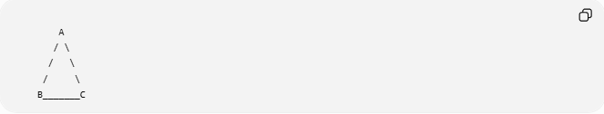
A
/ \
/ \
/ \
B_______C
Properties:
- Three sides have different lengths.
- Three angles may have different measures.

Irregular Quadrilateral
# Source: AI Source: Provided by: [Data Path: Persons Table -> ID Column: 1, Name_En Column: Motasem Essam] -> From: [ChatGPT] on [7/25/2026]
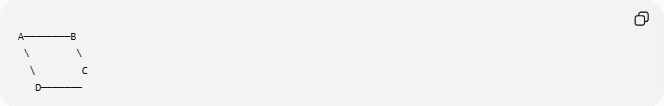
A────────B
\ \
\ C
D───────
Properties:
- Four sides are not necessarily equal.
- Angles are different.

Irregular Pentagon
# Source: AI Source: Provided by: [Data Path: Persons Table -> ID Column: 1, Name_En Column: Motasem Essam] -> From: [ChatGPT] on [7/25/2026]
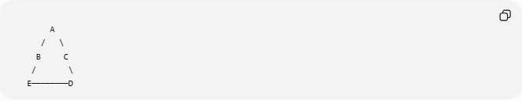
A
/ \
B C
/ \
E────────D
Properties:
- Five unequal sides.
- Unequal interior angles.

Mathematical Representation
# Source: AI Source: Provided by: [Data Path: Persons Table -> ID Column: 1, Name_En Column: Motasem Essam] -> From: [ChatGPT] on [7/25/2026]
An irregular polygon can be represented by a sequence of vertices:
$$P_{1},P_{2},P_{3},…,P_{n}$$
connected by line segments:
$$\overline{P_{1}P_{2}},\overline{P_{2}P_{3}},…,\overline{P_{n}P_{1}}$$
The side lengths are not equal:
$$\left|P_{1}P_{2}\right|≠\left|P_{2}P_{3}\right|≠\left|P_{3}P_{4}\right|$$
and the interior angles may differ:
$$θ_{1}≠θ_{2}≠θ_{3}$$

Types of Irregular Polygonal Shapes

1. Irregular Triangles
# Source: AI Source: Provided by: [Data Path: Persons Table -> ID Column: 1, Name_En Column: Motasem Essam] -> From: [ChatGPT] on [7/25/2026]
A triangle is irregular when its sides or angles are unequal.
Example:
Scalene Triangle
Properties:
- No equal sides.
- No equal angles.

2. Irregular Quadrilaterals
# Source: AI Source: Provided by: [Data Path: Persons Table -> ID Column: 1, Name_En Column: Motasem Essam] -> From: [ChatGPT] on [7/25/2026]
Four-sided irregular polygons.
Examples:
- Irregular rectangle.
- Irregular trapezoid.
- Irregular quadrilateral.

3. Irregular Pentagons
# Source: AI Source: Provided by: [Data Path: Persons Table -> ID Column: 1, Name_En Column: Motasem Essam] -> From: [ChatGPT] on [7/25/2026]
Five-sided polygons with unequal measurements.
Examples:
- Random pentagonal shapes.
- Asymmetric pentagons.

4. Irregular Hexagons
# Source: AI Source: Provided by: [Data Path: Persons Table -> ID Column: 1, Name_En Column: Motasem Essam] -> From: [ChatGPT] on [7/25/2026]
Six-sided polygons with unequal sides and angles.
Examples:
- Natural crystal outlines.
- Irregular floor patterns.

Classification by Shape Structure

Irregular Convex Polygon
# Source: AI Source: Provided by: [Data Path: Persons Table -> ID Column: 1, Name_En Column: Motasem Essam] -> From: [ChatGPT] on [7/25/2026]
A polygon where:
- All interior angles are less than:
$${180}^{∘}$$
- No inward dents exist.
Example:
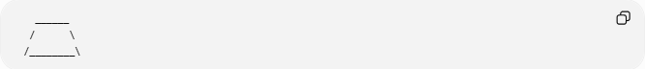
______
/ \
/________\

Irregular Concave Polygon
# Source: AI Source: Provided by: [Data Path: Persons Table -> ID Column: 1, Name_En Column: Motasem Essam] -> From: [ChatGPT] on [7/25/2026]
A polygon where:
- At least one interior angle is greater than:
$${180}^{∘}$$
Example:

______
/ \
| __ |
|__/ \_|

Properties
# Source: AI Source: Provided by: [Data Path: Persons Table -> ID Column: 1, Name_En Column: Motasem Essam] -> From: [ChatGPT] on [7/25/2026]
1. Unequal Sides
Unlike regular polygons:
$$a≠b≠c$$

2. Unequal Angles
Interior angles may have different values.

3. Variable Symmetry
An irregular polygon may have:
- No symmetry.
- Partial symmetry.

4. Complex Measurement
Area and perimeter often require:
- Decomposition.
- Coordinate geometry.
- Numerical methods.

Area Calculation Methods

1. Decomposition Method
# Source: AI Source: Provided by: [Data Path: Persons Table -> ID Column: 1, Name_En Column: Motasem Essam] -> From: [ChatGPT] on [7/25/2026]
Divide the irregular polygon into simpler shapes:
$$A=A_{1}+A_{2}+A_{3}+⋯+A_{n}$$
Example:
- Triangles.
- Rectangles.
- Trapezoids.

2. Shoelace Formula
# Source: AI Source: Provided by: [Data Path: Persons Table -> ID Column: 1, Name_En Column: Motasem Essam] -> From: [ChatGPT] on [7/25/2026]
For vertices:
$$\left(x_{1},y_{1}\right),\left(x_{2},y_{2}\right),...,\left(x_{n},y_{n}\right)$$
Area:
[
$$A=\frac{1}{2}\left|\sum_{i=1}^{n}{\left(x_{i}y_{i+1}-x_{i+1}y_{i}\right)}\right|$$]

Real-World Examples
# Source: AI Source: Provided by: [Data Path: Persons Table -> ID Column: 1, Name_En Column: Motasem Essam] -> From: [ChatGPT] on [7/25/2026]
Irregular polygonal shapes are found in:
- Land boundaries.
- Property maps.
- Lakes and islands.
- Building layouts.
- Mechanical parts.
- Machine components.
- Product designs.
- Natural crystals.

Applications
# Source: AI Source: Provided by: [Data Path: Persons Table -> ID Column: 1, Name_En Column: Motasem Essam] -> From: [ChatGPT] on [7/25/2026]
Irregular polygonal shapes are used in:
- Plane Geometry.
- Surveying.
- GIS (Geographic Information Systems).
- Architecture.
- Engineering.
- CAD (Computer-Aided Design).
- Computer Graphics.
- Robotics.
- Manufacturing.

Advantages
# Source: AI Source: Provided by: [Data Path: Persons Table -> ID Column: 1, Name_En Column: Motasem Essam] -> From: [ChatGPT] on [7/25/2026]
Studying irregular polygonal shapes helps to:
- Represent real-world objects accurately.
- Calculate complex areas.
- Model geographical regions.
- Design customized structures.
- Analyze engineering components.

Limitations
# Source: AI Source: Provided by: [Data Path: Persons Table -> ID Column: 1, Name_En Column: Motasem Essam] -> From: [ChatGPT] on [7/25/2026]
Irregular polygonal shapes:
- Lack simple formulas compared with regular polygons.
- Require more calculations.
- May need computer algorithms for complex shapes.
- Are harder to classify.

Comparison with Regular Polygonal Shapes
# Source: AI Source: Provided by: [Data Path: Persons Table -> ID Column: 1, Name_En Column: Motasem Essam] -> From: [ChatGPT] on [7/25/2026]
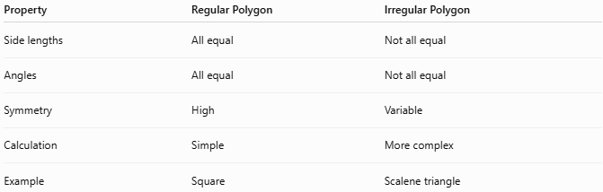
Property | Regular Polygon | Irregular Polygon
Side lengths | All equal | Not all equal
Angles | All equal | Not all equal
Symmetry | High | Variable
Calculation | Simple | More complex
Example | Square | Scalene triangle

Key Points
# Source: AI Source: Provided by: [Data Path: Persons Table -> ID Column: 1, Name_En Column: Motasem Essam] -> From: [ChatGPT] on [7/25/2026]
- An Irregular Polygonal Shape is a polygon with unequal sides and/or angles.
- It is made only from straight line segments.
- It can be:
  - Convex.
  - Concave.
- Common examples:
  - Scalene triangle.
  - Irregular quadrilateral.
  - Irregular pentagon.
  - Irregular hexagon.

Conclusion
# Source: AI Source: Provided by: [Data Path: Persons Table -> ID Column: 1, Name_En Column: Motasem Essam] -> From: [ChatGPT] on [7/25/2026]
An Irregular Polygonal Shape is a closed two-dimensional figure made entirely of straight line segments where the sides and/or angles are not all equal. These shapes are important in plane geometry, surveying, GIS, architecture, engineering, CAD, computer graphics, robotics, and manufacturing because they allow mathematical modeling of real-world objects and complex boundaries that do not follow regular geometric patterns.

